The maximum-subarray problem. You are predicting the price of a share by using a 'share price future prediction tool. You want to maximize the profit by following simple strategy 'buy low, sell high'. Consider following example, where horizontal axis indicates number of days, and

vertical axis shows the price.

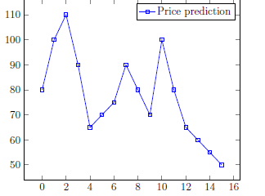

Write a program to identify the best time to buy and sell the share in order to

maximise pro_t.